CTC Loss and Decoding
(All answers should be in the notebook)

Problem Setup:
You are given:
- Probability Matrix (α from the forward pass):
The α-matrix which you will use to compute the final probability and CTC loss.

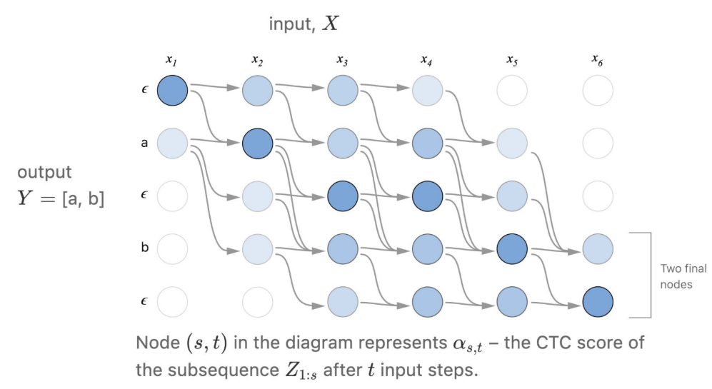

Assume D = 1 because D here is referred to dataset size and in the notebook we only work on one sample

2. Vocabulary (symbols and blank):
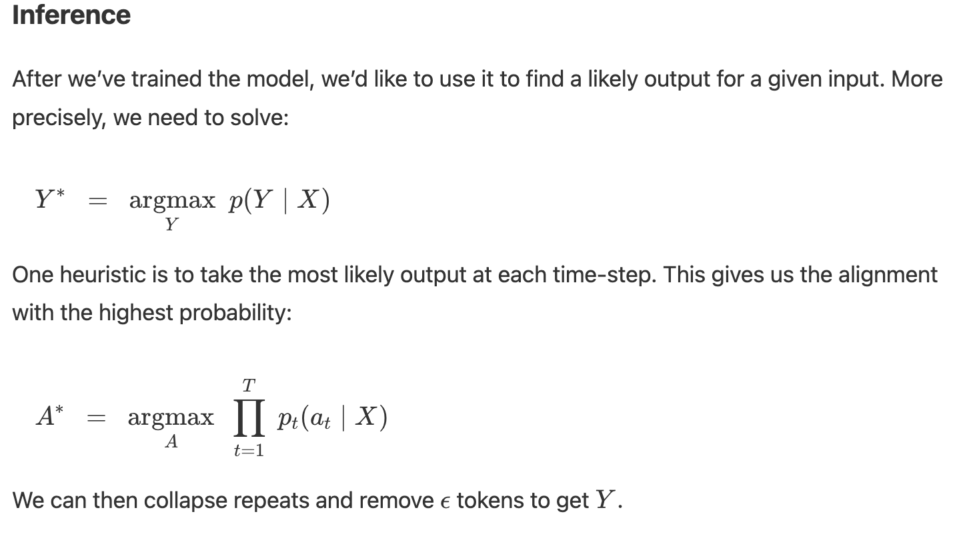
  - Vocabulary = ["a", "b", "c", "_"]

Discussion Questions:

- To compute the loss, I assume it was very simple. Clarify why it was that simple and why the numbers you take from this matrix were enough.

- If we are going to work on sentences rather than words, is a blank token enough? And if it isn’t enough, what should we do and why? And what code modifications will be needed?
(Explain in text the changes, do not write code in your answer)

- Is CTC using a better decoding strategy rather than the greedy one? Can you explain it briefly, the basic one and the one they modify to follow more sequence, and why they make this modification?

